**How to use to use the iQ manifest generation tool**

**Introduction**

The purpose of the manifest generation tool is to create a manifest file containing details of video file(s); the manifest file generated can then be used in the process of uploading videos onto the iQ system. This tool is not operating system dependent and will work on any system that has the required version (see prerequisites) of python install.

**Prerequisites**

* The system running the ***create_manifest*** tool must have python 2.7.x installed. Available from <https://www.python.org/downloads>
* The videos must be all in a single directory
* Files should be named using lowercase characters only otherwise, they will be renamed automatically when *create_manifest* is run.

**Generate manifest of video(s)**

1. Run ***create_manifest*** from the console (command line)



1. You will be prompted for the path to the folder containing the video files



1. Enter the path. For example ***C:\1s***



1. Press ENTER, the system will display the results and generate the manifest file.

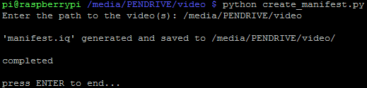

1. The manifest file generated will be saved to the same folder containing the video files.

1. Press enter to end the program.

*Note: If file names are not in lowercase characters, they will be automatically renamed to lowercase.*